Project Design Phase-II Data Flow Diagram & User Stories

|  |  |
| --- | --- |
| Date | 10 October 2022 |
| Team ID | PNT2022TMID22202 |
| Project Name | A New Hint To Transportation - Analysis of the NYC Bike Share System |
| Maximum Marks | 4 Marks |

# Data Flow Diagrams:

A Data Flow Diagram (DFD) is a traditional visual representation of the information flows within a system. A neat and clear DFD can depict the right amount of the system requirement graphically. It shows how data enters and leaves the system, what changes the information, and where data is stored.

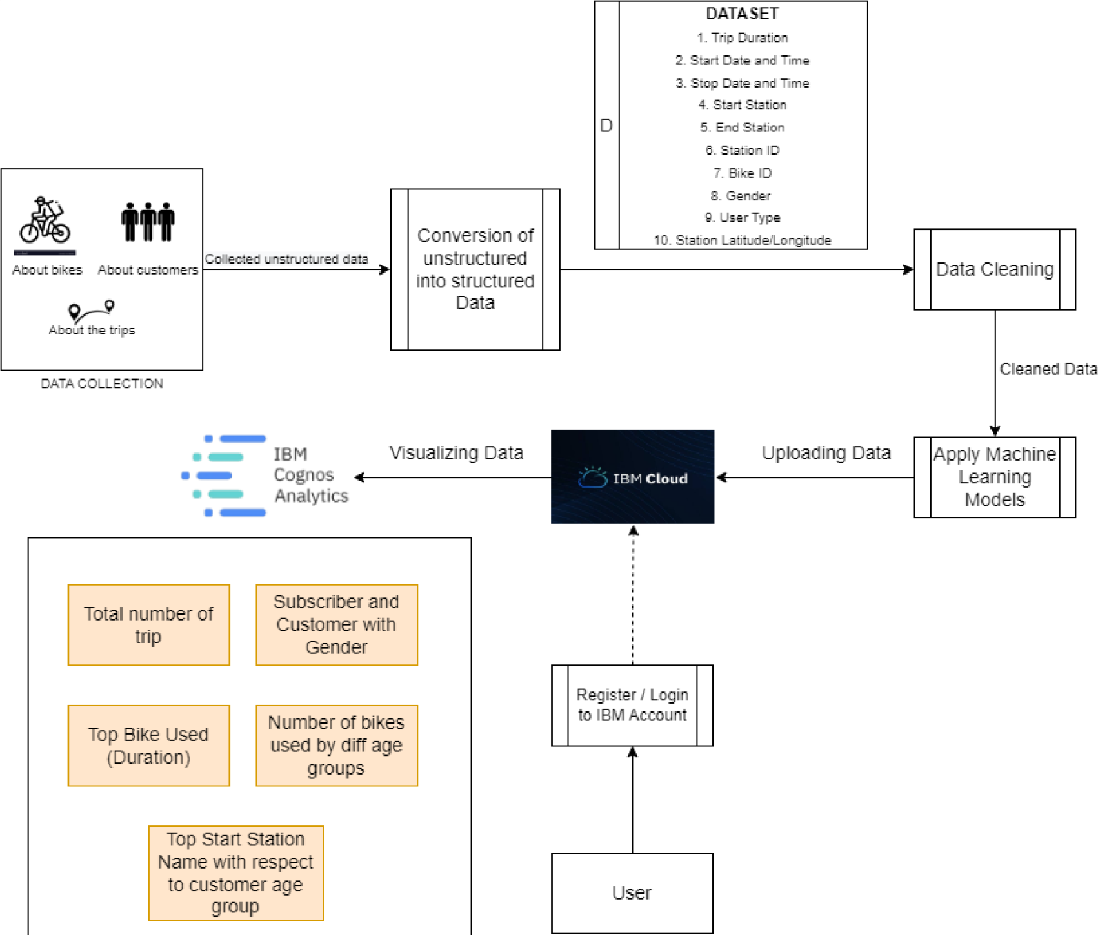

# User Stories

Use the below template to list all the user stories for the product.

|  |  |  |  |  |  |  |
| --- | --- | --- | --- | --- | --- | --- |
| **User Type** | **Functional Requirement**  **(Epic)** | **User Story Number** | **User Story / Task** | **Acceptance criteria** | **Priority** | **Release** |
| Customer(Analysts at Citi, Government) | Registration | USN-1 | As a user, I should be able to register to see the dashboard as a new user | Successful Registration | High | Sprint-1 |
| Customer(Analysts at Citi, Government) | Login | USN-2 | As a user I should be able to login to see the dashboard with the correct credentials | Succesful Login with correct credentials | High | Sprint-1 |
| Customer(Analysts at Citi, Government) | Accessing the dashboard | USN-3 | As a user, I should be able to view the visualizations displayed | Should be able to view the following analysis among others :   1. Total number of trips 2. Subscriber and Customer with gender 3. Top Bike used with respect to duration 4. Number of bikes used by different age groups 5. Top start station name with respect   to customer age group | High | Sprint-1 |
| Customer(Analysts at Citi, Government) | Manipulating the data | USN-4 | As a user I should be able to apply some  modifications to the data to see how the resultant visualizations change | I should have the  permission to manipulate the data | High | Sprint-2 |